COMPARISON OF THE TRAPEZIUS SQUEEZING TEST AND JAW THRUST AS OPTIMAL INDICATORS FOR LARYNGEAL MASK AIRWAY INSERTION IN ADULTS
Abstract:
BACKGROUND Laryngeal mask airway (LMA) insertion requires a certain depth of anaesthesia that blunts the airway reflexes. The purpose of this study was to compare the effectiveness of the trapezius squeezing test with that of the jaw thrust test as clinical indicators of adequate condition for LMA insertion in adults under propofol anesthesia.
METHODS: In this randomized study, seventy adult patients undergoing surgery with general anesthesia maintained with LMA were randomly allocated to the T (trapezius squeezing, n = 35) group or the J (jaw thrust, n = 35) group. The LMA was inserted immediately after the loss of response to trapezius squeezing or jaw thrust. Successful and unsuccessful attempts were recorded. An unsuccessful attempt was defined as development of coughing, SPO2 < 90%, body movements during or within one minute of LMA insertion and failed insertion of LMA. Preparation time for LMA insertion, blood pressure, heart rate was recorded.
RESULTS: The incidence of successful attempts was significantly higher in the T than in the J group (p value = 0.002). The preparation time taken for LMA insertion, arterial blood pressure, and heart rate were comparable in both the groups.
CONCLUSION: This study has demonstrated that the trapezius squeezing test is a superior indicator of an adequate condition for LMA insertion compared to the jaw thrust test in adults.
KEY WORDS: Jaw thrust, Laryngeal mask airway, Trapezius squeezing test

Text
Introduction:
Supraglottic airway devices have become a standard fixture in airway management, filling a niche between the face mask and tracheal tube in terms of both anatomical position and degree of invasiveness.¹ Successful insertion of LMA require the adequate depth of anesthesia. LMA if inserted under lighter planes of anesthesia can result in coughing, gagging, body movements, breath holding, and even rejection of LMA.² Clearly, a reliable, routinely performed clinical test for depth of anesthesia would help obviate such problems.³ An indicator should give precise information about anesthetic depth to avoid complications owing to deep or light anesthesia, and it should be a simple, repeatable, and accurate maneuver to perform .⁴ The loss of verbal contact, eyelash reflex, corneal reflex, loss of ability to hold light object, jaw relaxation, apnea and jaw thrust maneuver are often used as potential indicators of the optimal anesthetic depth for LMA insertion in adults.^{2,4,5} An alternative indicator such as trapezius squeezing test has been suggested as a useful indicator for LMA insertion.⁴
Trapezius squeeze test is a simple test to perform in which 1–2 inches of full thickness trapezius muscle is held and squeezed for 1–2 seconds and response evaluated in the form of toe/body movement. Negative response to trapezius squeeze is depicted by loss of toe or body movement. Trapezius squeeze test is technically easy to perform, free of side effects, and loss of response to squeeze provides excellent insertion condition. This test is repeatable and reproducible, and reliable end point.²
Jaw thrust maneuver consists of grasping and lifting the angles of the lower jaw with both hands, one on each side, while displacing the mandible forward.⁶ It imitate the stimulus that would be caused by insertion of the laryngeal mask. Thus, the loss of motor response to jaw thrust may indicate a level of anaesthesia deep enough to allow uncomplicated insertion of the mask.⁷ Thus, this study was conducted to make comparison between the effectiveness of the trapezius squeezing test with that of the jaw thrust test as clinical indicators of an adequate condition for LMA insertion in adults under propofol anesthesia.

Methods:
This prospective, randomized, single-blinded, comparative study was conducted in Department of Anaesthesiology, Institute of Medicine, Tribhuvan University Teaching Hospital (TUTH) over a period of four months. Study was approved by institutional Ethical committee.
Seventy adult patients of age 18 to 65 years with ASA physical status I/II in whom anaesthesia can be maintained in spontaneously breathing condition with an LMA were included in the study. Patients with predicted difficult airway, risk of aspiration, acute respiratory infection, psychiatric illness, allergic to propofol were excluded from the study.
The eligible patients were evaluated prior to surgery (preanesthetic check up).Written informed consent was taken. Age, sex and weight of the patient were recorded. Patient was kept nil per oral at least 6 hrs prior to surgery. Premedication was given 2 hrs prior to surgery (Tab diazepam 5mg for wt <50 kg, 10mg for wt> 50 kg). In the preoperative room IV access was secured with an 18 G cannula and IV drip was started with Ringer’s lactate. Patients were randomized into two groups by sealed envelope technique: trapezius squeezing test, group T (n=35) and jaw thrust, group J (n=35).
In the operating theatre, pulse oximetry, electrocardiogram, noninvasive arterial blood pressure were attached and recorded (Baseline). Preoxygenation was done via facemask with oxygen at 5 liters/min for three minutes. After preoxygenation, propofol 10 mg intravenously was given to the patient every five seconds until the negative test to either trapezius squeezing test and jaw thrust test. In the group T, the trapezius squeezing test was performed as soon as the patient lost verbal contact. Trapezius squeezing test was repeated every 10 seconds till it became negative. In group J, the jaw thrust was done as soon as the patient lost verbal contact. The jaw thrust test was repeated every 10 seconds till it became negative. After a negative response to trapezius squeezing or jaw thrust test as determined by attending consultant anesthesiologist, a well lubricated, appropriate size LMA was inserted. All laryngeal mask insertion and the tests were performed by same investigator.
The response of the patient to LMA insertion was classified as either ‘successful’ or ‘unsuccessful’ attempt by consultant anesthesiologist. ‘Successful’ attempt was identified if there was no coughing, SPO2 ≥ 90%, no body movement during or within one minute of LMA insertion. Development of coughing, SPO2 < 90%, body movements during or within one minute of LMA insertion and failed insertion of LMA was regarded as ‘unsuccessful’ attempt. The preparation time for LMA insertion was measured from propofol administration to the negative trapezius squeezing test or jaw thrust test. Effective ventilation was determined by observing chest wall movement, auscultation, and capnography.
Coughing during LMA insertion was recorded in three grades.⁸
1- None.
2- Less than or equal to two cough.
3- More than two cough.
The patient’s body movement during LMA insertion was classified in four grades.⁹
1- None.
2- Slight movement of the upper and/or lower extremities.
3- Moderate movement including the trunk.
4- Failed insertion of the LMA with a marked movement
LMA if could not be inserted at the first attempt after negative test, the patient was further managed accordingly at the discretion of consultant anesthesiologist. However the condition during LMA insertion was only graded at the first attempt. After LMA insertion anesthesia was maintained with oxygen, isoflurane and fentanyl.
Data were collected in preformed data collection sheet and were analyzed using statistical package for the social sciences (SPSS) software version 20 using appropriate statistical tests. Independent samples test was used for analysis of age wise distribution, weight wise distribution, preparation time taken for LMA insertion and hemodynamic parameters. Chi-Square test was used for analysis of gender wise distribution, incidence of cough and movement and response to LMA insertion. p value < 0.05 was interpreted as statistical significant.

Results:
Demographic data were comparable in both the groups (Table 1). The differences between two groups in respect to incidence of cough (p = 0.019) and body movement (p = 0.019) were statistically significant (Table 2). There was unsuccessful insertion of LMA in 21 patients in group J and 8 patients in group T. The difference between response to LMA insertion in two groups was statistically significant (p=0.002) (Table 3). The preparation time taken for insertion of the LMA in group J was 80.5 ± 19.3 seconds when compared to 81.1 ± 14.6 seconds in group T and it was not statistically significant (p =0.879). All patients remained hemodynamically stable during the procedure (Figure 1).
Table 1: Demographic distribution
Parameter |  | Group J  (n = 35) | Group J  (n = 35) | p value
Mean Age(yrs) ± SD |  | 31.7 ± 12.1 | 29.8 ± 10.67 | 0.486
Gender | Male | 20 (57%) | 19 (54%) | 0.810
 | Female | 15 (43%) | 15 (43%)
Mean Body Weight (kg) ± SD |  | 57.05 ± 9.19 | 57.9 ± 7.5 | 0.671

Table 2: Incidence of Coughing and Movement
Parameter | Grade | Description | Group J  (n = 35) | Group T  (n = 35) | p value
Cough | 1 | No cough | 20 | 29 | 0.019
 | 2 | ≤2 cough | 7 | 4
 | 3 | >2 cough | 8 | 2
Movement | 1 | None | 25 | 31 | 0.023
 | 2 | Slight movement of upper and lower extremities | 4 | 4
 | 3 | Moderate movement including trunk | 5 | 0
 | 4 | Failed insertion of LMA with marked movement | 1 | 0

Table 3: Response to LMA insertion
Response | Group J (n = 35) | Group T (n = 35) | p value
Successful insertion | 14 (40%) | 27 (77%) | 0.002
Unsuccessful insertion | 21 (60%) | 8 (33%)

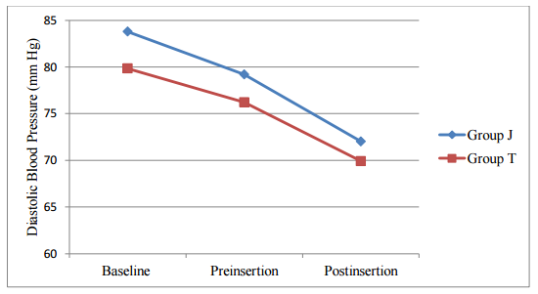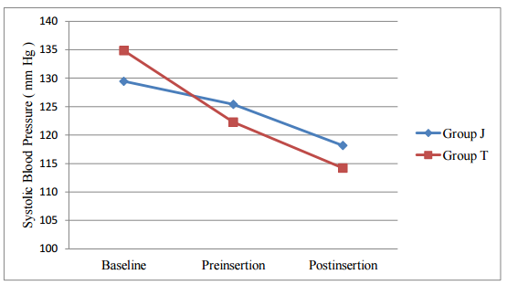
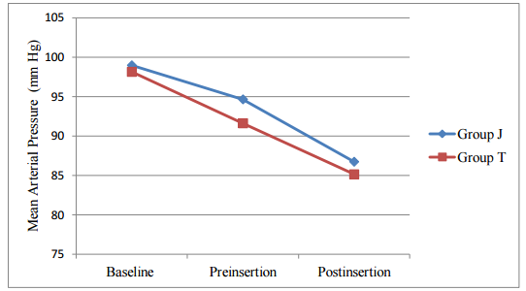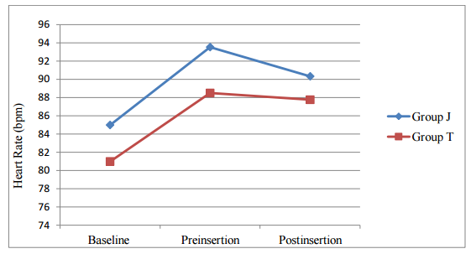
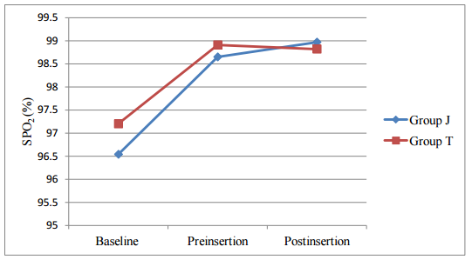

Figure1: Changes in hemodynamic

Discussion:
Assessment of the depth of anaesthesia is fundamental to anaesthetic practice. One of the objectives of modern anaesthesia is to ensure adequate depth of anaesthesia without overdosing the patients with potent drugs. There appears to be increasing evidence that anaesthesia depth measurement improve the quality of anaesthesia.¹⁰ Deep anesthesia is essential to obtund airway reflexes and hemodynamic responses and for obtaining optimal conditions for LMA insertion.
Anesthesiologists commonly encounter airway complications during LMA insertion such as coughing, gagging, hiccups, or aspiration.¹¹ However, the LMA can be inserted smoothly after suppression of airway reflexes with adequate anesthesia. An ideal method to detect optimal anesthetic depth for LMA insertion must be easy to perform, harmless to the patient and repeatable. The assessment of depth of anesthesia using clinical indicators involves the observation of responses after application of stimulus. Many clinicians use loss of verbal contact and eyelash reflex or jaw relaxation as a clinical marker of optimal anesthetic depth.⁵
There have been a very few studies^{2,4,5} on trapezius squeeze test predicting the depth of anesthesia for LMA insertion till date. Our study was performed to compare trapezius squeezing test and jaw thrust as indicators for laryngeal mask airway insertion in adults. The main objective of our study was to compare the incidence of coughing and body movement, preparation time taken for LMA insertion and hemodynamic parameters between the trapezius squeezing test and jaw thrust test. Our study shows that the trapezius squeezing test is a reliable and useful clinical indicator to assess adequate depth of anesthesia for LMA insertion.
Successful insertion of LMA requires adequate depth of anesthesia by either inhalational or intravenous anesthesia to suppress the pharyngeal and laryngeal reflexes. To date, for LMA insertion, propofol is the intravenous drug of choice as it provides rapid relaxation.¹² No study has been conducted with propofol as induction agent comparing trapezius squeeze test and jaw thrust. Most of the studies have been done with sevoflurane.^{2,4,5} Several studies have shown that induction of anaesthesia after inhalation of sevoflurane is comparable with IV propofol.^{13,14} Even some study has found propofol being superior to sevoflurane for insertion of the Laryngeal Mask Airway.¹⁵ This study may be the first study to compare trapezius squeeze test and jaw thrust using propofol for LMA insertion.
The demographic characteristics of the patients in both jaw thrust and trapezius group were comparable in our study. There was no significant difference in patient distribution in terms of age, gender and weight between the two groups. Laryngeal Mask Airway placement requires suppression of the sensitive hypopharynx for successful placement as well as attenuation of the laryngeal reflexes.¹⁵ Adverse response like coughing during LMA insertion is undesirable. In our study, we have found significant decrease in incidence of cough in trapezius squeeze group as compared to jaw thrust (p = 0.019). This finding is similar to study done by Chang CH et al.⁴ where trapezius squeeze test was compared with jaw thrust test using sevoflurane.
Laryngeal mask airway is generally inserted without any muscle relaxant; however, insertion of the LMA requires a sufficient depth of anesthesia to suppress the upper airway reflex and patient movement.⁹ Body movement during LMA insertion can cause rejection of LMA.² There was less incidence of body movement in trapezius group test after insertion of LMA (p = 0.023). Similar result was observed by Chang CH et al.⁴ when comparing trapezius squeeze test with jaw thrust. Townstead R et al.³ obtained the optimal condition for LMA insertion in 76% patients with jaw thrust using fentanyl and propofol as induction agent. Similarly Drage MP et al.⁷ suggested that jaw thrust is a reliable marker of successful LMA insertion in adults with an 87% success rate, which was higher than that in this study (40%).The reason behind such big difference in success rate of jaw thrust may be attributed to the combined use of fentanyl and propofol in their study whereas our study used propofol only as sole induction drug. Kodaka et al.¹⁶ also demonstrated more success rate of LMA insertion with less body movement with propofol- fentanyl compared to propofol-saline group.
Trapezius squeezing, checked by squeezing the trapezius muscle and observing the motor response, is a well-known stimulus to assess the anesthetic depth during LMA insertion. Our study had shown significantly higher number of successful insertions of LMA in trapezius squeeze group as compared to jaw thrust group (77% vs. 40%). These observations are comparable to study of Chang CH et al.⁴ Thus, trapezius squeeze test had better predicted the sufficient anesthetic depth for LMA insertion preventing complications such as cough, and patient movement.
The preparation time for LMA insertion as noted from propofol administration to the negative trapezius squeezing test or jaw thrust test was comparable in both the group. The mean time was 81.1 ± 14.6 (SD) seconds in trapezius squeeze group and in jaw thrust group it was 80.5 ± 19.3 (SD) seconds (p = 0.879). Preparation time of sixty to ninty seconds after routine propofol induction has provided excellent placement condition for LMA insertion in study done by Sheu R et al.¹⁷ The insertion time from sevoflurane inhalation induction to LMA insertion when guided by the trapezius squeezing test and jaw thrust test was 4.1 minutes and 2.5 minutes respectively in Chang CH et al.⁴ study. Shorter time for LMA insertion in our study was due to faster onset of induction with propofol. There was no evidence of laryngospasm, gagging, breath holding reported during the insertion time of LMA in both of study groups.
Both the groups exhibited stable hemodynamic profiles. In our study we didn’t use bolus dose of propofol, this could be the reason behind stable hemodynamic seen in our patients in both the groups. Stokes et al.¹⁸ also noted that decrease in rate of administration decreases not only the dose of propofol, but also the degree of adverse hemodynamic events. Postoperative problems like pain at squeeze site and evidence of trauma like ecchymosis were not noticed in any group.
Our study has several limitations. First, our findings may not apply to other insertion techniques (such as the laryngoscope-guided technique) or other laryngeal mask airway devices (such as the intubating LMA), as the level of stimulation may be different. Second, our findings may not apply to other induction agents, particularly those that are less effective at obtunding upper airway reflexes, such as thiopentone.¹⁹ Third, we did not determine the optimal level of jaw thrust and the squeezing power for trapezius squeeze test. However all the tests were conducted by single investigator in order to maintain the uniformity.
The use of the trapezius squeezing test can be recommended for assessing the adequate anesthetic depth for LMA insertion in adults. Further studies comparing the trapezius squeezing test and jaw thrust for LMA insertion with other anesthetic induction agents are recommended.

Funding: Nil
Acknowledgments: Nil
Conflict of interest: No stated conflict of interest among the authors
References:
- Dorsch JA, Dorsch SE. Understanding anaesthesia equipment. 5 th Ed. Lippincott Williams & Wilkins, 2008.Chapter17, Supraglottic Airway Devices; p.461-500.
- Hooda S, Kaur K, Rattan KN, Thakur AK, Kamal K. Trapezius squeeze test as an indicator for depth of anesthesia for laryngeal mask airway insertion in children. J Anaaesthesiol Clin Pharmacol.2012 Jan;28(1):28-31.
- Townsend R, Brimacombe J, Keller C, Wenzel V, Herff H. Jaw thrust as predictor of insertion conditions of proseal laryngeal mask. Middle East J Anesthesiol. 2009 Feb;20(1):59-62.
- Chang CH, Kim SH, Shim YH, Kim JH, Shin YS. Comparison of the trapezius squeezing test and jaw thrust as indicators for laryngeal mask airway insertion in adults. Korean J Anesthesiol. 2011 Sep; 61(3):201-4.
- Chang CH, Shim YH, Shin YS, Lee KY. Optimal conditions for Laryngeal Mask Airway insertion in children can be determined by the trapezius squeezing test. J Clin Anesth. 2008 Mar; 20(2):99-102.
- Albrecht E, Patrick S. Images in clinical medicine. The jaw-thrust maneuver. N Engl J Med. 2010 Nov 18;363(21).
- Drage MP, Nunez J, Vaughan RS, Asai T. Jaw thrusting as a clinical test to assess the adequate depth of anaesthesia for insertion of thelaryngeal mask. Anaesthesia. 1996 Dec;51(12):1167-70.
- Park HJ, Kang SH. Comparison of Propofol ED and Insertion Conditions of LMA between Fentanyl and Alfentanil Adjuvant Group.Korean J Anesthesiol.2007 Jun; 52(6):21-24.
- Kanazawa M, Nitta M, Murata T, Suzuki T. Increased dosage of propofol in anesthesia induction cannot control the patient's responses to insertion of a laryngeal mask airway. Tokai J Exp Clin Med. 2006 Apr 20;31(1):35-8.
- Priya V, Divatia J, Dasgupta D. A comparision of propfol versus sevoflurane for laryngeal mask airway insertion, Indian J. Anaesth. 2002;46 (1):31- 34.
- Asai T, Morris S. The laryngeal mask airway: its features, effects and role. Can J Anaesth. 1994 Oct;41(10):930-60.
- Sinha R, Snedhe D, Garg R. Comparision of propofol (1%) with admixture (1:1) of thipentone (1.25%) and propofol (0.5%) in children undergoing eye surgery. Indian J Anaesth. 2010 Mar;54(2):104-8.
- Ti LK, Chow MY, Lee TL. Comparison of Sevoflurane with Propofol for Laryngeal Mask Airway insertion in adults. Anesth Analg. 1999 Apr;88(4):908- 12.
- Molloy ME, Buggy DJ, Scanlon P. Propofol or Sevoflurane for Laryngeal Mask Airway insertion. Can J Anaesth. 1999 Apr;46(4):322-6.
- Priya V, Divatia J, Dasgupta D. A comparision of propfol versus sevoflurane for laryngeal mask airway insertion, Indian J. Anaesth. 2002;46 (1):31- 34.
- Kodaka M, Okamoto Y, Handa F, Kawasaki J, Miyao H. Relation between fentanyl dose and predicted EC50 of propofol for laryngeal mask insertion. Br J Anaesth. 2004 Feb;92(2):238-41.
- . Sheu R, Downey R, Bonney I, Contant C, Zhao P. The Optimal Timing of Laryngeal Mask Airway Insertion With Propofol Induction. [Internet].2012 [cited20120ct12].Availablefrom:http://www.asaabstracts.com/strands/asaabstrac ts/abstract.htm.
- Stokes DN, Hutton P. Rate dependent induction phenomenon with propfol: implications for the relative potency of intravenous anesthetics. Anesth Analg. 1991 May;72(5):578-83.
- Scanlon P, Carey M, Power M, Kirby F. Patient response to laryngeal mask insertion after induction of anaesthesia with propofol of thiopentone. Can J Anaesth.1993 sep;40(9):816-8.

